HSV Quilt Guild, Inc.
July 2021 Block of the Month

The July block of the month is Block 11, Five and Nine, from the Moda Stitch Pink challenge. The block is available here: https://my.modafabrics.com/webfiles/fp_stitch-pink2020_11_five-and-nine.pdf
The only helpful hint I can offer is that you should square up the nine patch units before assembling the final block.
Here is a photo of my completed block:
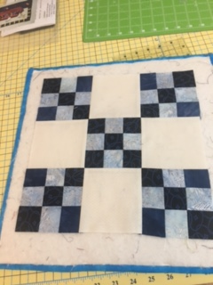

Enjoy!

