HSV Quilt Guild, Inc.
September 2021 Block of the Month

The September block of the month is Block 1, Underdog, from the Moda Stitch Pink challenge. The block is available here: https://my.modafabrics.com/webfiles/fp_stitch-pink2020_1_underdog.pdf
Some helpful hints:
- This block uses three fabrics: background; light and medium
- For the C units (the quarter square triangle units), I used 2 6” blocks of fabric C, and one 6” square each of fabrics D and E and constructed the units using this method: https://thecraftyquilter.com/2012/02/quarter-square-triangle-tutorial/
- Square up your units to 4.5x4.5” before assembling them
- Otherwise, I made the block as written.
Here is a photo of my completed block:
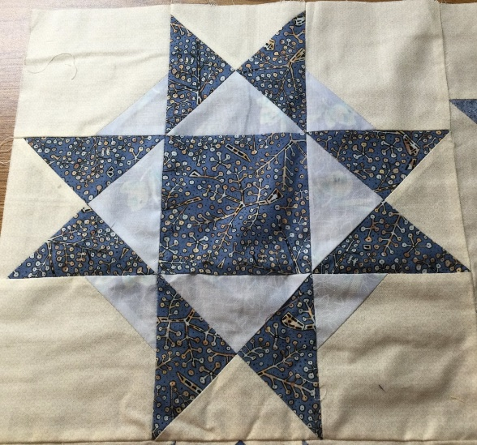
Enjoy!

