HSV Quilt Guild, Inc.
April 2021 Block of the month

The April block of the month is Block 23, Fixer Upper, from the Moda Stitch Pink challenge. The link is: https://my.modafabrics.com/webfiles/fp_stitch-pink2020_23_fixer-upper.pdf.
I don't have any helpful hints, except that this block is tricker than you might think, so be aware of color changes and how the interim 6-1/2 units go together. I did some ripping on this deceptively simple block!
Here is a photo of my completed block:

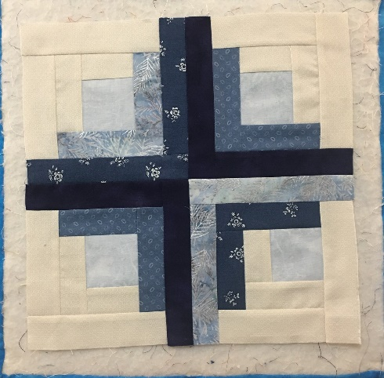
Enjoy!

