HSV Quilt Guild, Inc.
May 2021 Block of the month

The April block of the month is Block 16, Just Call Me A Diva, from the Moda Stitch Pink challenge. The block is available here: https://my.modafabrics.com/webfiles/fp_stitch-pink2020_16_just-call-me-a-diva.pdf
Insofar as helpful hints, the only thing I did differently than the written instructions was to make the D/E quarter square triangles from squares rather than cutting the triangles. If you decide to do the same, you will need two 4.5” squares of fabrics D and E for these units. An easy method for making this unit from squares can be found here: https://www.generations-quilt-patterns.com/quarter-square-triangles.html
Here is a photo of my completed block:
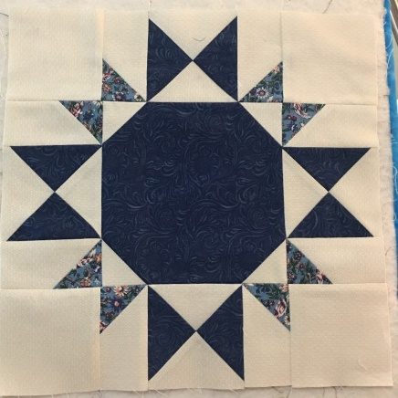

Enjoy!

