HSV Quilt Guild, Inc.
June 2021 Block of the Month

The June block of the month is Block 20, Blow Me A Kiss, from the Moda Stitch Pink challenge. The block is available here: https://my.modafabrics.com/webfiles/fp_stitch-pink2020_20_blow-me-a-kiss.pdf
The only helpful hints I have for this simple, but not easy, block are:
- There are only three colors. The pieces of each are cut in a variety of sizes.
  - Dark
  - Very light
  - Background
  - It helps to lay the pieces out on a design board to help keep them in order. You can make a very simple board with scraps of foam core board, batting, and duct tape or binding. See https://www.youtube.com/watch?v=1nSZtoionpA for a quick video tutorial.
- Trim after EVERY round so that your final block is 12.5 inches square, as you would do for a log cabin block.

Here is a photo of my completed block (on one of my very old and much used design boards):
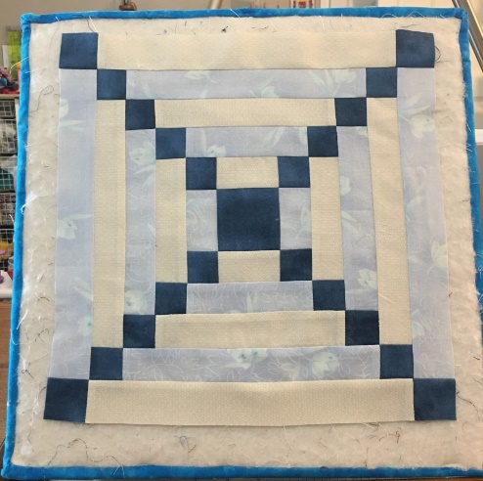

Enjoy!

