HSV Quilt Guild, Inc.
August 2021 Block of the Month

The August block of the month is Block 19, Tropicana, from the Moda Stitch Pink challenge. The block is available here: https://my.modafabrics.com/webfiles/fp_stitch-pink2020_19_tropicana.pdf
Some helpful hints:
- Press or mark the diagonals on the background fabric with a removable marker to align the petals. It is really hard to get them right without this step.
- A handy tutorial for the “flip and fuse” method is here: https://my.modafabrics.com/inspiration-resources/stitch-pink-block-19
- Instead of using the “flip and fuse” method, you can fuse and sew around the petals with your choice of stitch. Be sure to use a tear-away stabilizer if you choose this method.
Here is a photo of my completed block:
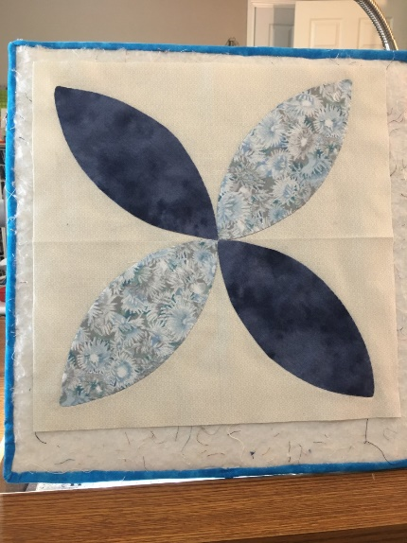

Enjoy!

