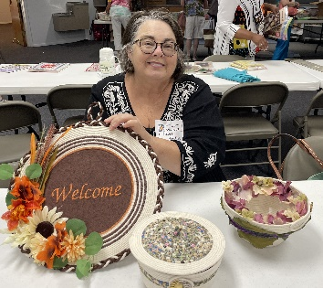
February 13, 14
A Rope Bowl Extravaganza
Presented by: Carol Welle
Class Time: Thursday 12:30 – 3:30 Beginning Rope Bowls
Class Time: Friday 9:00 – 3:30 Next Steps for Rope Bowls
Thursday Class Fee: $20.00 Friday Class Fee: $25.00
Rope: $9.00 per spool (100 feet)

Thursday: Beginning Rope Bowls Class Fee: $20.00
If you’ve never made a rope bowl and are wondering what all the fuss is about, this class is for you. You’ll learn about starting a coil, creating a strong base, shaping and angling the sides, and several finishing techniques. We’ll talk about the pros and cons of different types of ropes and machines needed to achieve the angle on the sides. You will leave the class with a finished bowl like the one below.
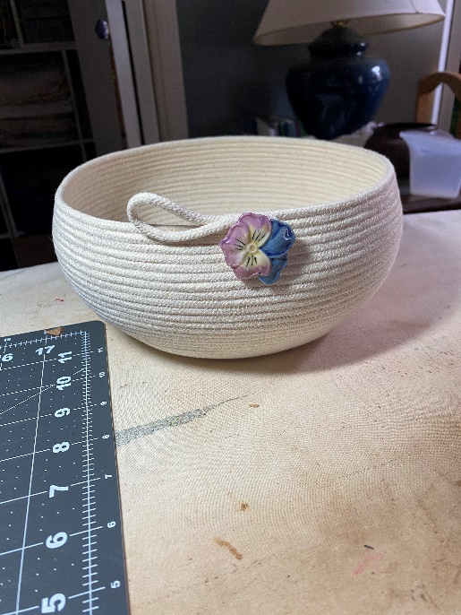
Supply List: sewing machine thread - white is suggested, scissors for cutting your rope (not your good ones), extra needles for your machine, ruler, sharpie marker (any color), seam ripper (just in case), 1 spool Hyper Tough 3/16 inch Diamond Braided Cotton Clothes Line, 100 feet (Walmart)

February 14
Friday – Next Steps for Rope Bowls Class Fee $25.00
Friday morning’s activities will teach you to add fabric to your bowl base and add a wrapped accent on several rows of coils. We’ll use fabric techniques to make a bowl similar to the one we made on Thursday.
Friday afternoon will find us exploring oval bowl construction. The base will be wrapped in fabric, and the bowl's body will have a decorative construction technique that you can use on other bowls you make. If time permits, we’ll explore rope-joining techniques.
Supply List: sewing machine, ¾ of fabric, thread (white and a color that compliments your fabric), scissors for rope and fabric, cutting mat, extra machine needles, ruler, rotary cutter, ½ yard Wonder Under or similar adhesive product, glue stick, ink pen, iron, and surface, big-headed pins, small clamps (multi-colored clamps), small broach, pin, or large button for embellishment (I will have covered button forms for embellishment), 2 spools Hyper Tough 3/16 inch Diamond Braided Cotton Clothes Line, 100 feet (Walmart).
