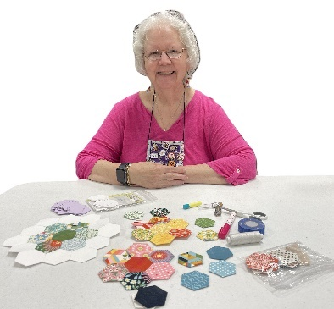

**January 9**

**Hexies and Beyond EPP Trunk Show**

**Presented by: Glenda Kirsch**

***Class Time*: Thursday 12:30 – 3:30 Class: EPP Made Simple**

**Cost: $20.00**

Join us for a fun and inspiring EPP trunk show. Glenda and her friends will share their lovely EPP quilts with us. They will share many examples and you’ll have the opportunity to ask questions.

**Class**: Glenda will share her years of hand-sewing expertise to guide us on our EPP journey. As an experienced EPP she will share tips and tricks to help beginners and seasoned English paper piecers. She’ll discuss everything from prepping and basting your blocks to fussy cutting and mirroring to achieve beautiful results. EPP is sewing that can go with you anywhere making it your on-the-go sewing project.

**Supplies**: Fabric (pack of 2 ½” squares), Glue Stick, small sewing scissors, Hand sewing needles ((a little thicker than a quilting needle), thimble, thread (50 weight in a neutral color like gray), templates( will be supplied)